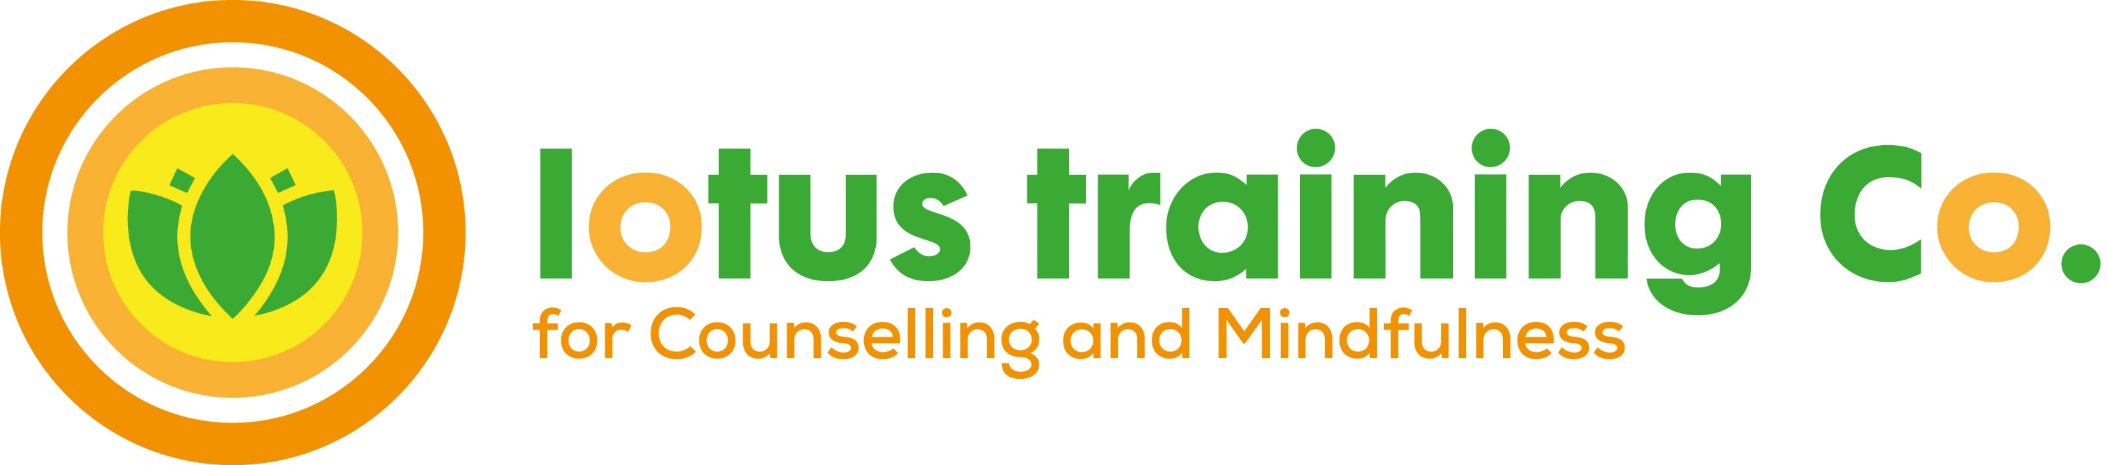
Level 2 Certificate in Counselling Studies
Start Date Monday 13th Sept 2021
5.45-9pm
Session No: Date: Topic
1 13th Sept Intro, ‘who are you now’
2 20th Sept ‘Who are you as a learner’
3 27th Sept Listening skills, open & closed questions
4 4th Oct Listening skills, open & closed questions
5 11th Oct Listening skills, summarising
6 18th Oct Assessment and Portfolio
SAT WORKSHOP 23rd Oct TBC A day of mindfulness
7 25th Oct Total Communication (1)
8 1st Nov Total Communication (2)
9 8th Nov Total Communication (3)
10 15th Nov Ethics and Safety
Sat Workshop 20th Nov TBC A day of mindfulness
11 22nd Nov Boundaries of the helping role
12 29th Nov Boundaries of the helping role
13 6th Dec Staying Present
14 13th Dec Mock exam
Winter Break 14th Dec – 9th Jan Time for a break
15 10th Jan Mock Exam Review & Mid-way Review
17 17th Jan External Assessment
18 24th Jan Developing an awareness of ‘self’.
Sat Workshop 29th Jan TBC A day of mindfulness
19 31st Jan Use of self-awareness/Focus on helpee
20 7th Feb Use of self-awareness/Focus on helpee
21 14th Feb Feedback and Reflection
22 21st Feb Course Review/endings & celebrations

Saturday workshops will be 5.5 hours long: 10:00am-3:30pm

Assignments
- Essay assignment: due 18th October 2021
- Recorded skills assignment: 6th December 2021
- Self-review
- Reflective Learning Journal, an entry for each session

