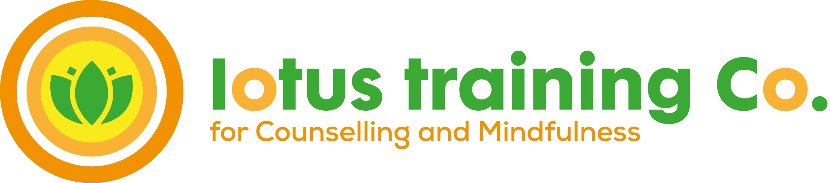
Level 3 Certificate in Counselling Studies
Start Date Tuesday 8th March 2022
5.45-9.00pm
Session No: Date: Topic
1 8th Mar Beginnings
2 15th Mar Person Centred Theory and Practice.
3 22nd Mar CBT and Mindfulness
4 29th Mar Gestalt theory and practice
Sat Workshop 2nd Apr Exploring Ethics
5 5th Apr Use of self in the counselling process
Easter Holidays
6 26th Apr What is counselling supervision
7 3rd May Supervision theories and practice
8 10th May Researching an agency
9 17th May What is Wellbeing
Sat Workshop 21st May Difference and Diversity
10 24th May Preparing for the exam
Half Term
11 7th June Exam Review
12 14th June External Assessment
13 21st June Structuring the therapeutic process
14 28th June Structuring the therapeutic process
15 5th July Skills Practice
Sat Workshop 9th July A day of Mindfulness
16 12th July P/C Approach and group dynamics
17 19th July Skills Practice
18 26th July Case Presentation
Summer Break
19 13th Sept Case Presentation
20 20th Sept Case Presentation
21 27th Sept Theoretical input on CMH diagnosis
22 4th Oct Creative ways of working
Sat Workshop 8th Oct Course review, celebrations, where next

Assignments
- Essay assignment: Theory essay due in by 24th May 2021
- Research projects as relevant. E.g Theory, Agency setting; Wellbeing; CMPH’s
- Case Study and Group supervision
- Self-review, 19th July 2021
- Audio recording with verbatim transcripts and tutor obs
- Reflective journal for each session

