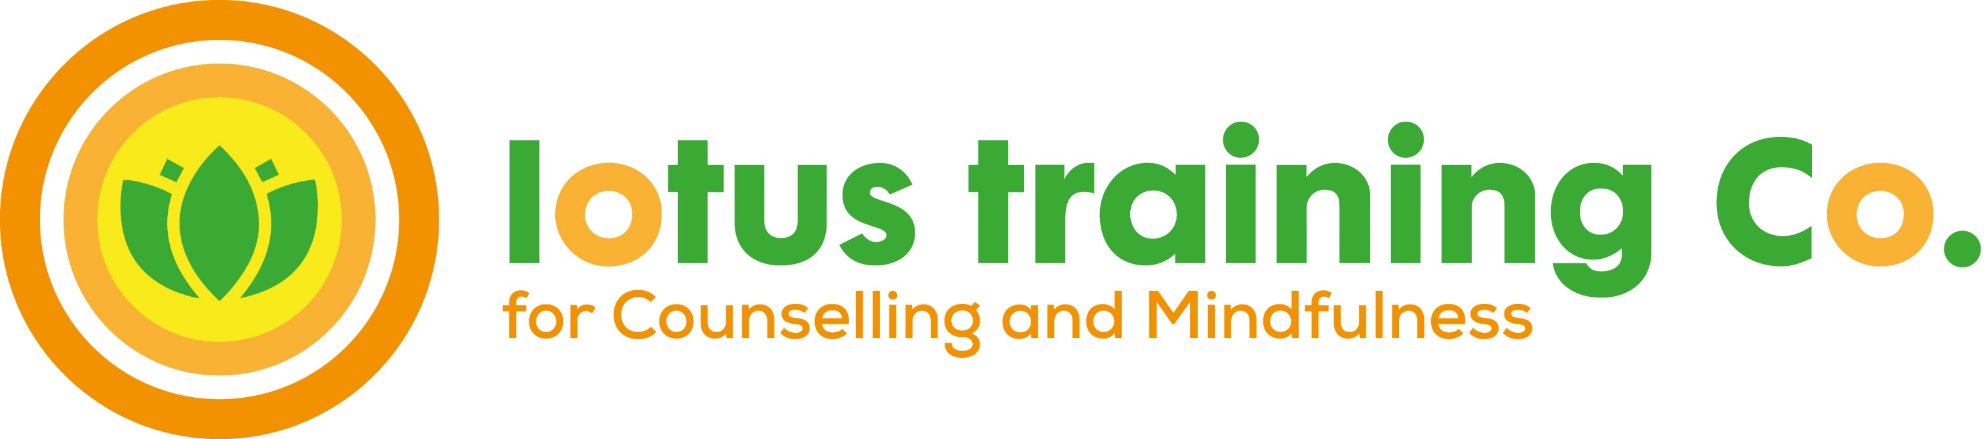
Level 2 Certificate in Counselling Studies
Start Date Monday 12th Sept 2022
5.45-9pm
Session No: Date: Topic
1 12th Sept Intro, ‘who are you now’
2 19th Sept ‘Who are you as a learner’
3 26th Sept Listening skills, open & closed questions
4 3rd Oct Listening skills, open & closed questions
5 10th Oct Listening skills, summarising
6 17th Oct Assessment and Portfolio
SAT WORKSHOP 22nd Oct TBC A day of mindfulness
7 24th Oct Total Communication (1)
8 31st Oct Total Communication (2)
9 7th Nov Total Communication (3)
10 14th Nov Ethics and Safety
Sat Workshop 19th Nov TBC A day of mindfulness
11 21st Nov Boundaries of the helping role
12 28th Nov Boundaries of the helping role
13 5th Dec Staying Present
14 12th Dec Mock exam
Winter Break 13th Dec – 8th Jan Time for a break
15 9th Jan Mock Exam Review & Mid-way Review
17 16th Jan External Assessment
18 23rd Jan Developing an awareness of ‘self’.
Sat Workshop 28th Jan TBC A day of mindfulness
19 30th Jan Use of self-awareness/Focus on helpee
20 6th Feb Use of self-awareness/Focus on helpee
21 13th Feb Feedback and Reflection
22 20th Feb Course Review/endings & celebrations

Saturday workshops will be 5.5 hours long: 10:00am-3:30pm

Assignments
- Essay assignment: due 17th October 2022
- Recorded skills assignment: 5th December 2022
- Self-review
- Reflective Learning Journal, an entry for each session

